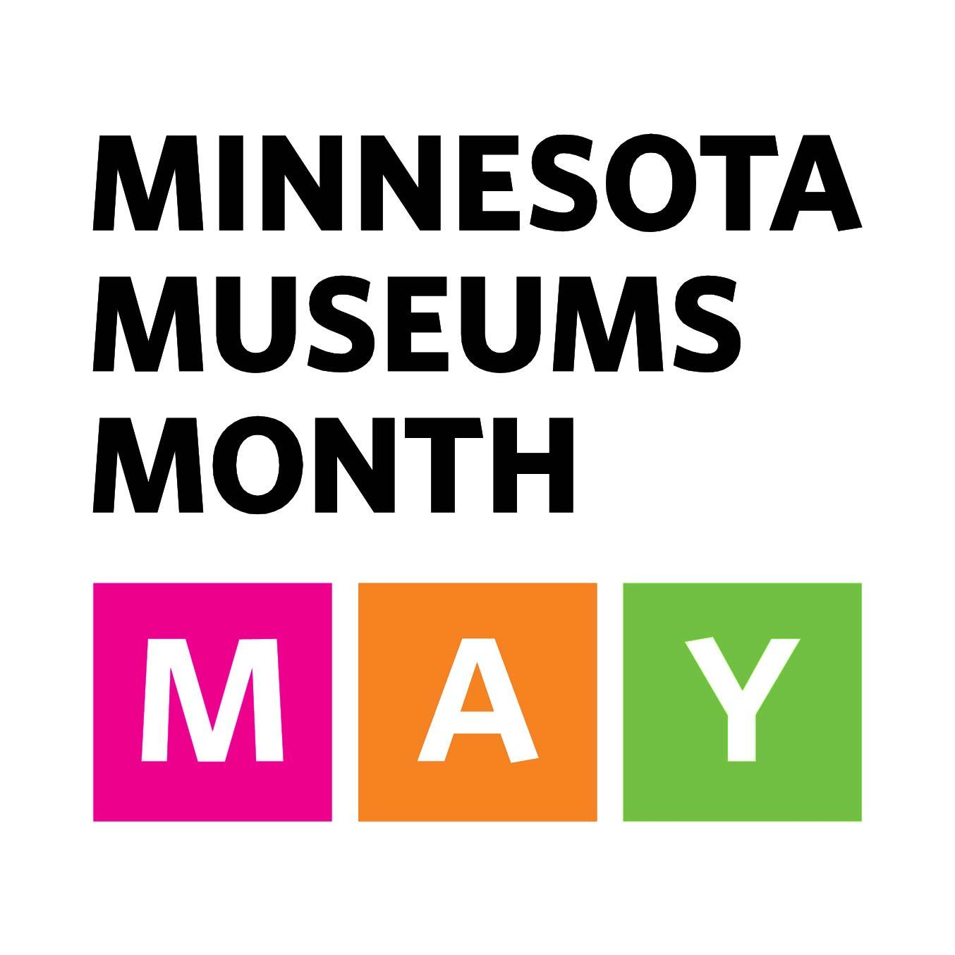

[MUSEUM NAME] to celebrate Minnesota Museums Month in May

Statewide Celebration Invites All Minnesotans to Discover the Wide Offerings of Minnesota Museums and Their Communities.

[DATE] 2017—[INSERT MUSEUM NAME] is participating in Minnesota Museums Month. The annual tradition is a collaboration among museums of all types—history, art, science, zoos, gardens, and more—to raise awareness and celebrate the importance of museums around the state. This month, you are encouraged to visit sites and institutions in our community and across our great state. With at least one museum in every Minnesota county, there is no shortage of opportunities to explore!

Minnesota is one of only a few states in the country that dedicates an entire month to celebrating the rich cultural resources of its museums. Here, communities recognize the important role local museums have as not only tourist destinations, but also as partners for economic development and cultural exchanges.

[INSERT QUOTE FROM MUSEUM SPOKESPERSON]

“Today, more than ever, museums are an integral part of the foundation of our civic life in America. They help us to face the challenges of the future, grounded in the lessons of our shared history.” —Ford Bell, former president of the American Alliance of Museums.

Since its inception in 2012, Minnesota Museums Month has come to be a celebration of our shared communities, histories, and cultures. Throughout May, [INSERT MUSEUM] is opening their doors to [INSERT PROGRAMMING INFORMATION/COLLECTIONS HIGHLIGHTS/WAYS VISITORS CAN PARTICIPATE IN MAY]. You are invited to this month-long party, so stop in for an adventure at one of Minnesota’s great museums.

For more information about Minnesota Museums Month, visit minnesotamuseums.org. Visitors are encouraged to share their adventures on social media using #mnmuseums.

ABOUT [INSERT MUSEUM NAME & INFORMATION]
ABOUT THE MINNESOTA ASSOCIATION OF MUSEUMS
The Minnesota Association of Museums (MAM) is a nonprofit organization that exists to provide a forum for individuals who work in and with museums throughout the state. Its goals are to foster and encourage communication among museum professionals in Minnesota, increase the visibility of MAM and promote Minnesota museums as a public resource for learning and recreation, and provide educational opportunities and training for museum professionals.

